1 day of EC2 instance.  
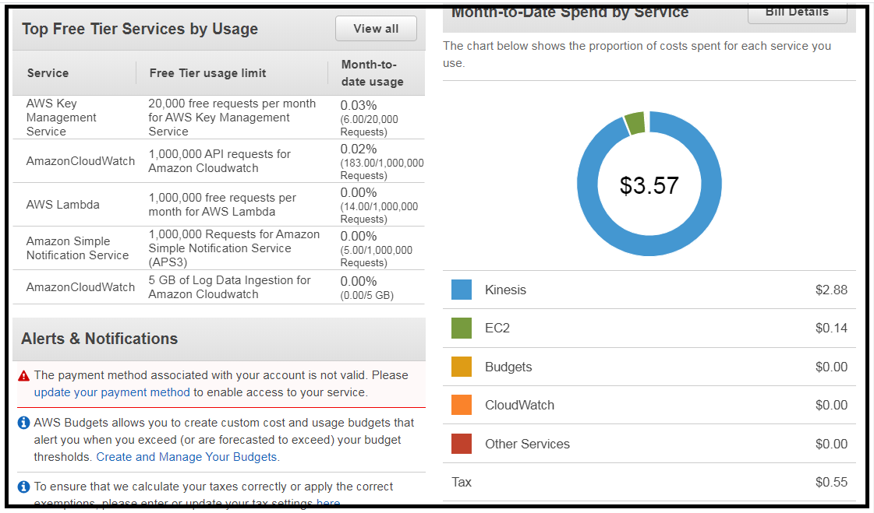  
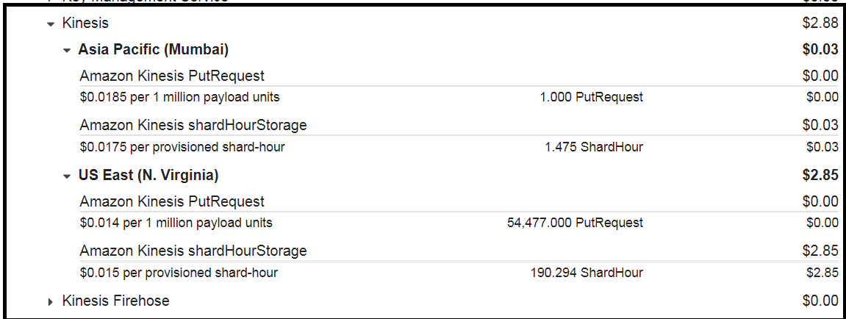  
  
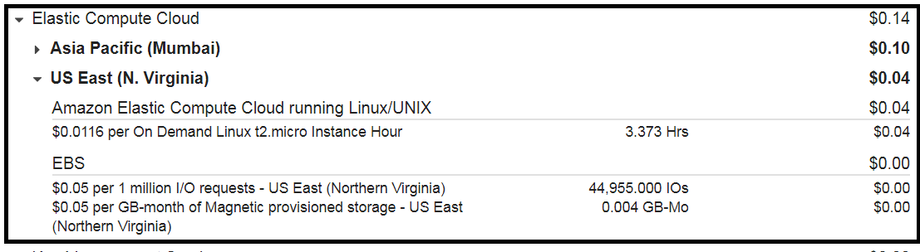

July 22, 2020 stats.  
Not sure if I ever provisioned an on-demand instance.  
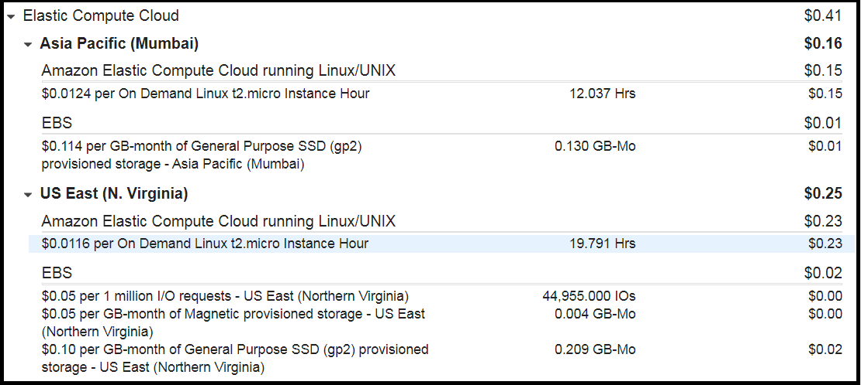  
  
5.AFTER UPLOADING A 4GB ISO IMAGE AND DOWNLOADING ITTHE SAME DAY – WE GOT THIS CHARGE.  
UPLOADED TO S3 STANDARD TIER STORAGE.  
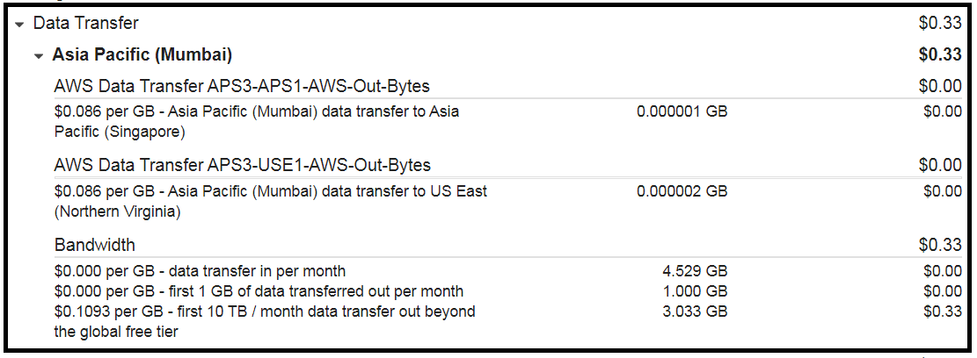  
  
  
  
6. EC2 instances created as part of beanstalk deployment.  
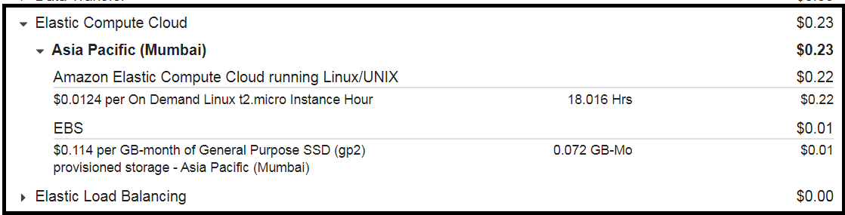s